## LAB 2: Network Traffic and Troubleshooting

In this exercise, we will go through the process of trouble-shooting the network setup and initial configuration.

1. After creating an Enforcement Point, the first place to check is the Firewall Dashboard to see if the statement count has incremented. This is updated once a minute.

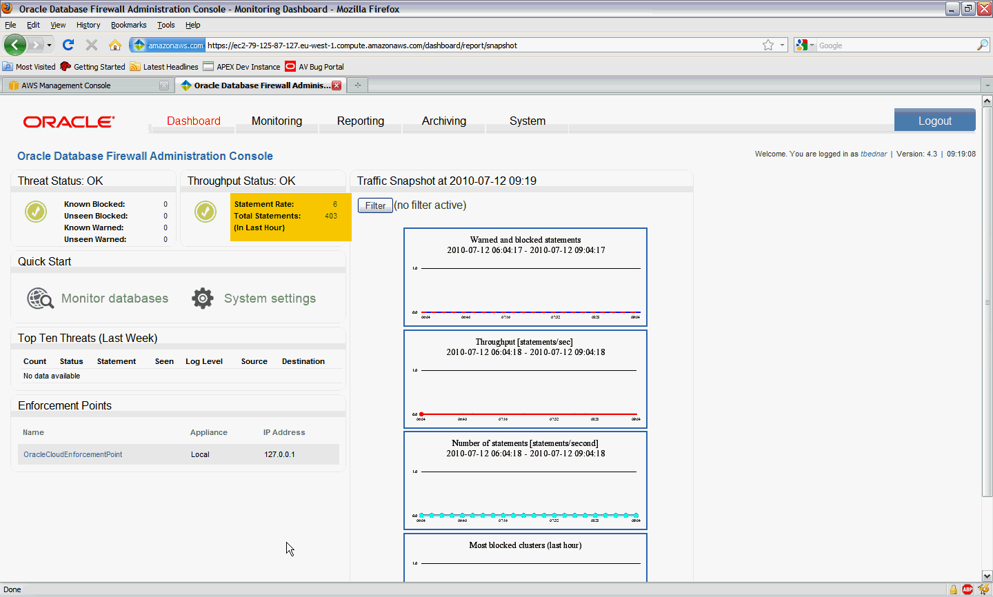

1. In a situation where the statement count is not incrementing, you would then go to the System tab, and click on Show under Network Traffic.

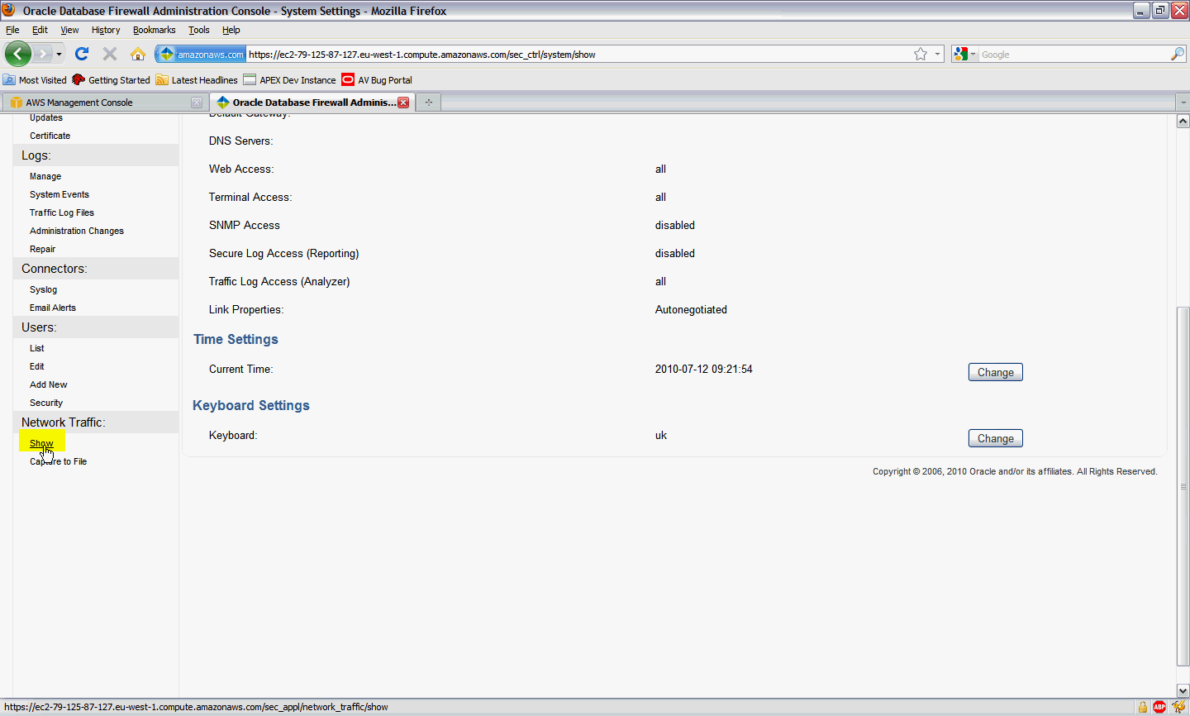

1. On the filter, select the protected database, set duration to 30 seconds and Press Show. Go to windows client and run the Oracle workload. This will display a summary of traffic flowing through the firewall.

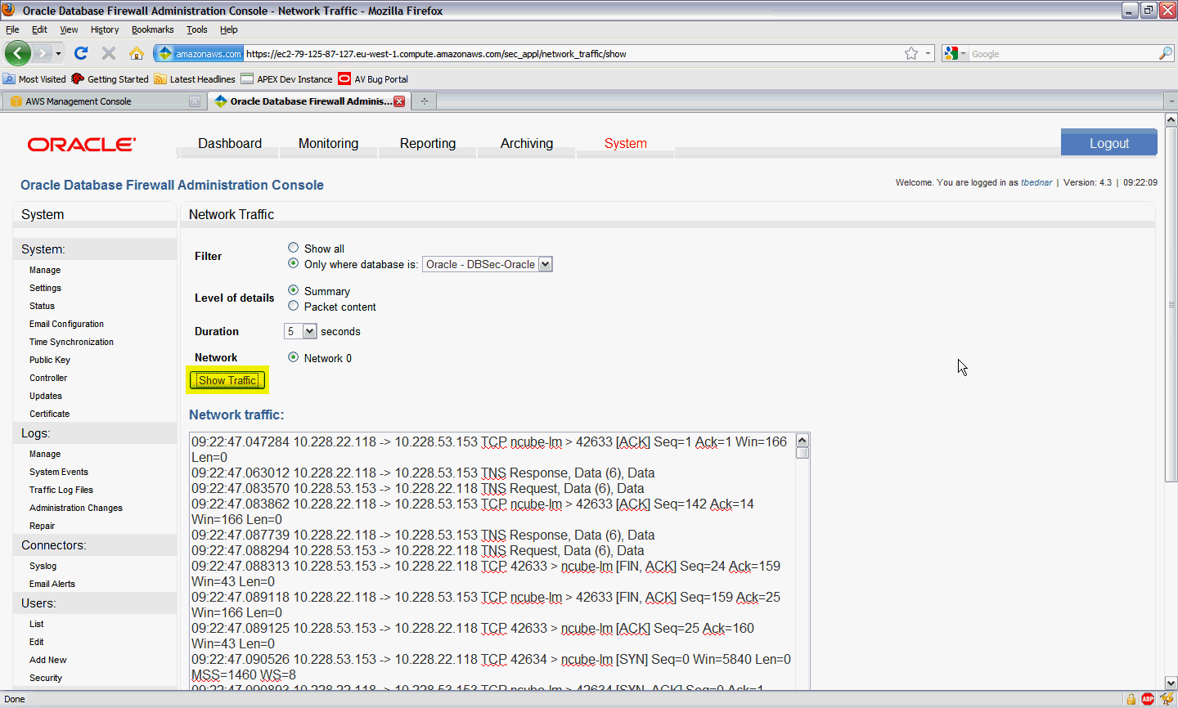

If no traffic is detected, there is an error with protected database settings or the network configuration. When no traffic is shown, go through this step again, but this time set the Filter to Show All. If nothing shows, there is an error with the network configuration. If TNS connections are present, it suggests the Protected Database settings are incorrect. Check the IP addresses of the Protected Database (accessed via the Monitoring tab).

1. Under the System tab, click on Traffic Log Files. If the firewall is successfully collecting SQL traffic, you will see one or more traffic log files. In Test mode, a new file will be created every minute.

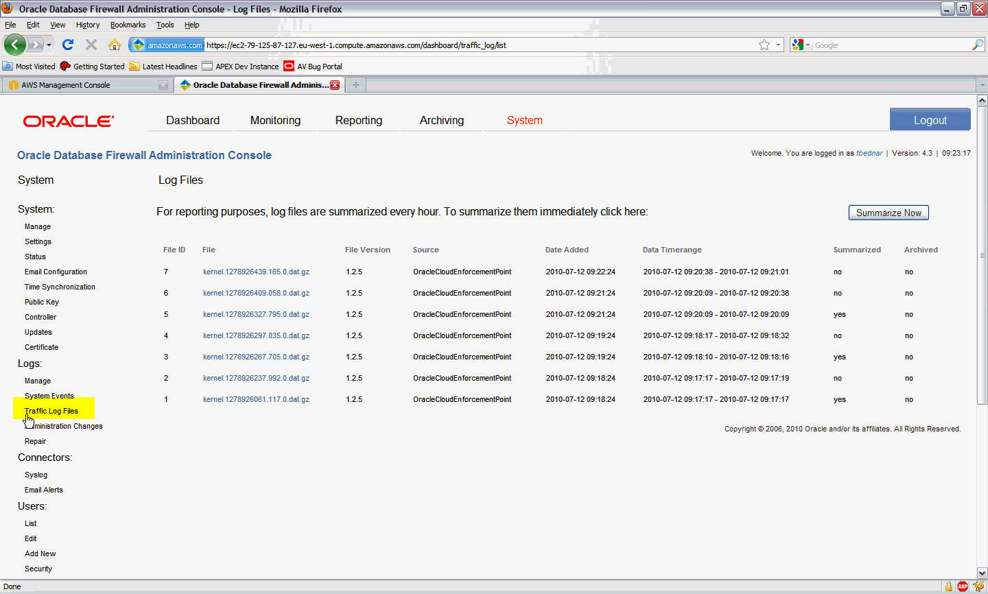

1. To view the statements being captured in ‘near’ real time, click on the Reporting tab, and under the Traffic Log menu, click on View.

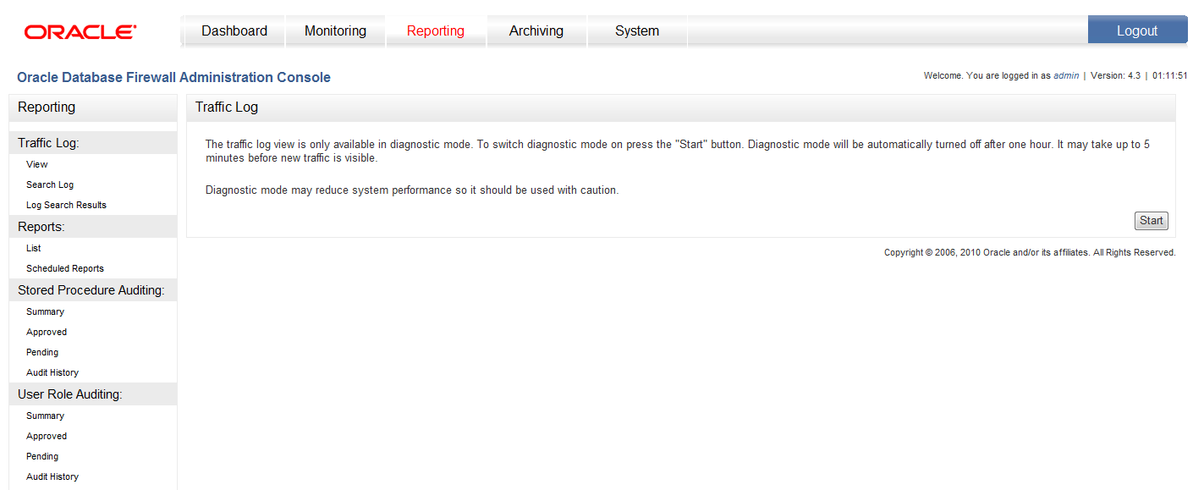

1. Click on Start on the right-hand side to begin monitoring for captured statements. It may take up to 5 minutes for new statements to appear if the Firewall has not been switched to Test configuration under the System, Manage menu.  
     
   